Karstadt Portal Access check

1. Go to to <https://628471438687.signin.aws.amazon.com/console>
2. Login with personal credentials. (DAS ID will be unique for each user)

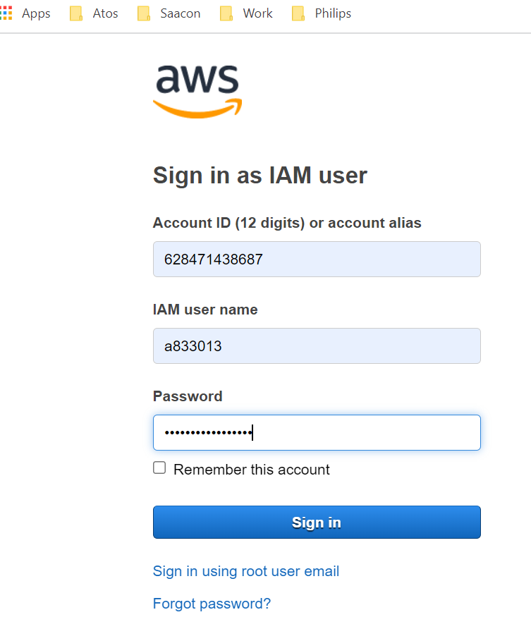

3. Click on Frankfurt region for karstadt.

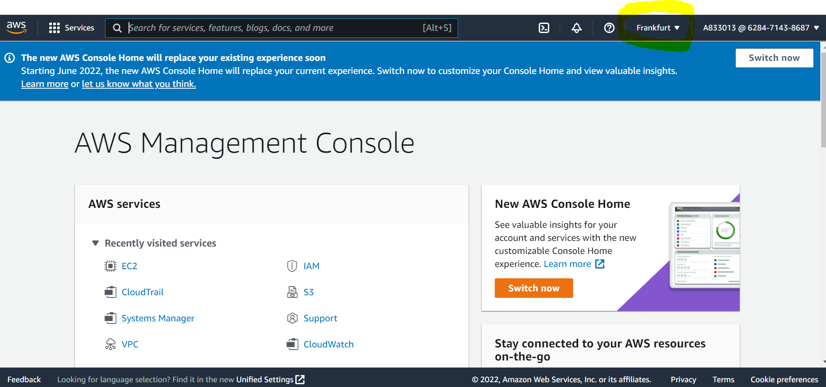

4.Click on extensions to switch in other accounts

